1. **Log in functionality with different credentials**

**Log in page:**

Log in page with username and password field.

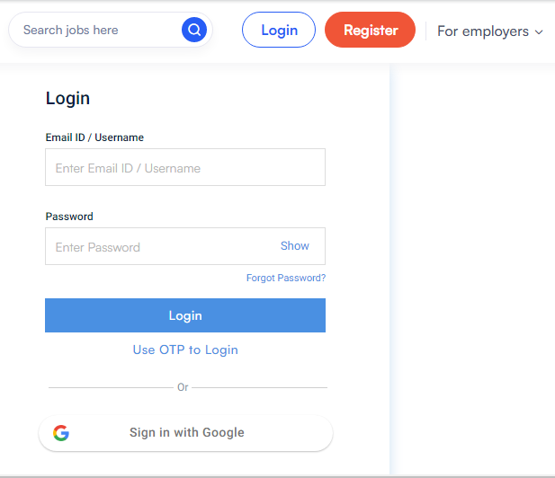

**Valid credentials:**

It is redirecting to the correct page while entering correct username and password.

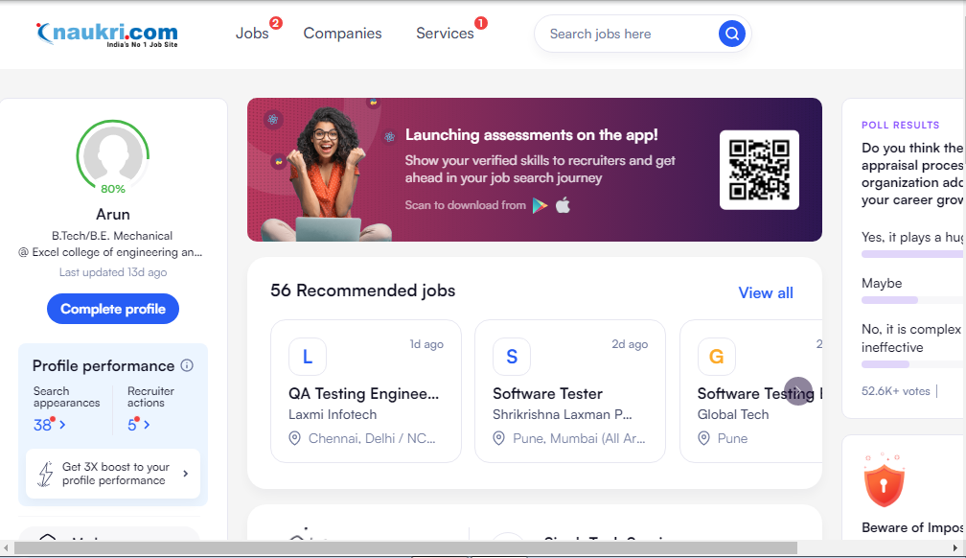

**Invalid** **credentials**:

It shows error message as invalid username and password whole entering incorrect password.